Personalised Website Builder
Product Requirements Document (PRD)
Product | KDK Sites: Personalised Website Builder
Product owner | KDK Software (appadmin@kdksoftware.com)
Maintainer | Kartik Khandelwal (Kartik.khandelwal@kdksoftware.com)
Status | Phase 1: working prototype, live and in active development
Audience | Everyone: leadership, product, design, developers, support, sales

HOW TO READ THIS How to read this document: it is written in plain language on purpose, so anyone at KDK can pick it up and understand what the product is, why it exists, who it's for, and exactly what it does today, not just the engineers building it. Every screen described below is shown with a real screenshot taken directly from the working product, not a mockup. Where a rule needs to be exact (for example, a validation rule a developer must build to), it is spelled out in full rather than summarised.

1. Purpose of This Document
This document is the single source of truth for the Personalised Website Builder. It describes exactly what the product does today, screen by screen, along with the reasoning behind each decision, so anyone at KDK can understand the product without needing a separate conversation.
Everything in this document describes the product as it works today, not a future plan.

2. Executive Summary
Most Chartered Accountants, Advocates, Tax Consultants, GST Practitioners, Company Secretaries, and Cost Accountants in India do not have a website. Getting one built the traditional way is expensive, slow, and requires technical knowledge they don't have and don't want to learn.
The Personalised Website Builder solves this by letting any of these professionals create a complete, professional, mobile-friendly website in under 10 minutes, either by:
- Answering simple questions themselves in a guided, 6-step wizard, or
- Letting an AI writer do it for them: a short interview where they describe their practice in their own words, and the AI writes all the website copy.
Once published, the website goes live immediately at its own web address, collects enquiries from visitors into a built-in inbox, and can be edited or taken offline at any time. No developer, no waiting, no separate invoice.
The product is a working prototype, live for real use. It is not yet part of KDK's official commercial offering: pricing and packaging are still to be decided.

3. Background

3.1 The Problem
Talk to any small or mid-sized CA firm, law office, or tax practice in India, and the story is the same:
- A website costs ₹15,000 to ₹80,000 through a freelancer or agency.
- It takes 4 to 8 weeks to get anything live.
- They don't have anyone in-house who can build or update it.
- Once it's live, even a simple change (a new phone number, a new service) means going back to whoever built it, and often paying again.
The result: the overwhelming majority of these professionals either have no website at all, or a hopelessly outdated one, at exactly the time when a prospective client's first move is to search for them online.

3.2 Goals
- Let a non-technical user go from nothing to a published, professional website in under 10 minutes. The entire value proposition collapses if it needs a developer or takes hours.
- Make every published site look genuinely professional, never generic or “templated”. A cheap-looking website damages credibility for a CA or Advocate more than having none.
- Capture enquiries directly from the website, in one place the professional already checks. The website must generate business, not just exist as a brochure.
- Never let a real, published website show placeholder or sample content. A firm's website carrying someone else's demo address, quotes, or numbers is a trust-breaking failure, not a cosmetic bug.
- Increase how much value each existing KDK customer represents. This is a new product line inside an existing relationship, not a new customer to acquire.
- Keep the product usable and distinct-looking at scale (hundreds or thousands of live sites). A template-based builder risks every site looking the same once there are many of them.

3.3 Who This Is For
The builder currently serves six professions. Each gets a starter set of services pre-loaded so the user isn't starting from a blank page:
Profession | Pre-loaded services
Chartered Accountant | Income Tax Return filing, GST, Tax Audit, TDS, ROC filings, NRI services
Advocate / Lawyer | Civil, Criminal, Corporate law, Tax litigation, Property matters
Tax Consultant | ITR filing, TDS, Tax planning, NRI tax, IT notices
GST Practitioner | GST registration, Returns filing, GSTR-9, Notice handling
Company Secretary | Company incorporation, ROC filings, FEMA compliance, Board meetings
Cost Accountant | Cost audit, CAS compliance, Management accounting, Budgeting

A typical user: runs a small-to-mid-sized practice, is comfortable with WhatsApp and basic apps, but has never built a website and doesn't want to learn HTML, hosting, or design software.
There is also a second, indirect user of this product: the visitor to a published site (a prospective client of the professional). Their needs matter too: the site must load fast, read clearly on a phone, and make it obvious how to make contact.

4. Product Scope

4.1 What's In Scope (Phase 1, current)
- A guided, 6-step wizard covering design, business details, content, services, and publishing
- An AI Website Writer that can fill out the entire site from a short conversational interview
- A login system, so a professional's site and drafts are saved to their account
- Four website designs, each with six colour options, so no two firms need to look identical
- A built-in enquiries inbox: every message a visitor sends is saved, searchable, exportable, and trackable by status
- Hosting and a live web address the moment the user clicks Publish, with the ability to take a site offline (and bring it back online) at any time
- A WhatsApp chat button on every published site
- Mobile-responsive design and automatic SSL (the padlock/https that browsers require)
- Automatic groundwork for the site to be found on Google

4.2 What's Deliberately Out of Scope (Phase 1)
- Custom domains (a firm's own .com, rather than a KDK-provided address)
- A client-facing portal or login on the published website
- A blog or multi-page sites: every published site is a single page
- Payment collection or an appointment-booking system on the site
- Automatic import of a professional's existing KDK profile data into the site

5. The Complete User Journey

5.1 User Flow Diagram
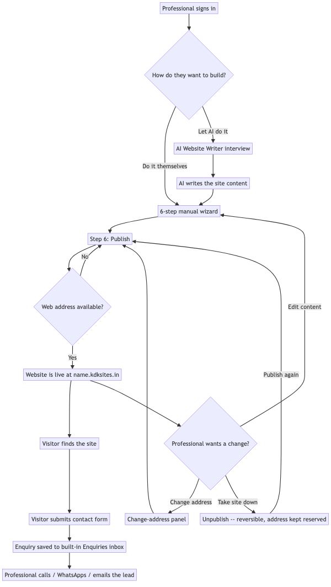
End-to-end flow: sign-in, build (manual or AI), publish, enquiries, and ongoing edits.

5.2 Signing In & Your Account
The builder is protected by a login screen (email and password). Signing in loads the user's saved site straight into the builder, exactly as they last left it, whether it's a draft or already published.
The account card in the bottom-left corner of the builder (name, email, and initials) opens the account menu when clicked:
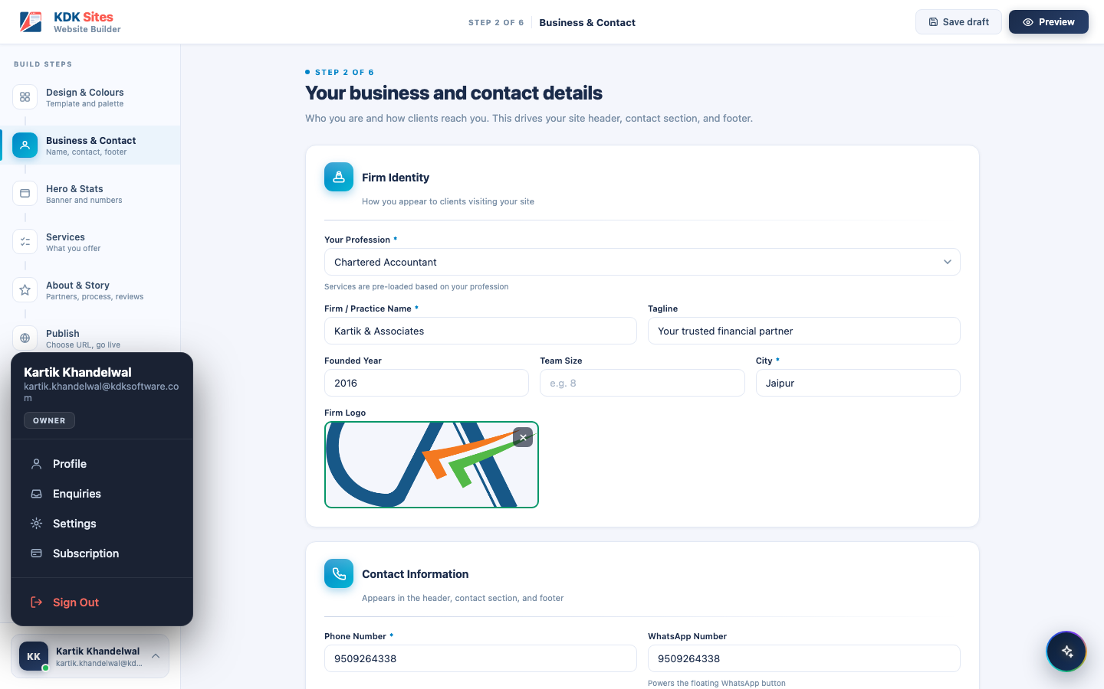
The account menu, opened from the bottom-left profile card
Menu item | What it does today
Profile | Placeholder: not yet built
Enquiries | Opens the same Enquiries inbox described in Section 5.6
Settings | Placeholder: not yet built
Subscription | Placeholder: not yet built
Sign Out | Ends the session and returns to the login screen. Also clears anything saved only on this device (an in-progress draft, AI Writer answers not yet saved to the cloud), so the next person to sign in on this device never sees a previous user's unsaved work.

Only Enquiries and Sign Out are functional at the moment. Profile, Settings, and Subscription are reserved slots for later: account details, notification preferences, and whatever future commercial features get decided, respectively.

5.3 Two Ways to Build: Do It Yourself, or Let the AI Do It
Every user can either:
- Work through the 6-step wizard below at their own pace, filling in each screen, or
- Open the AI Website Writer (a floating button, always available) and answer a short set of questions in plain conversational language. The AI then writes the entire site's content for them, and drops it straight into the same 6 steps.
Both paths lead to the exact same place: a finished configuration ready for Step 6 (Publish). Most users are expected to prefer the AI path; the manual steps stay available for anyone who wants full control, or wants to fine-tune what the AI produced.

5.4 The 6-Step Manual Builder
Step | Name | What the user does
1 | Design & Colours | Pick one of 4 website designs, then one of 6 colour palettes for that design
2 | Business & Contact | Firm name, profession (which loads the right starter services), phone, email, office address, office hours, social links
3 | Hero & Stats | The main banner text visitors see first, plus up to 6 key numbers (e.g. years in practice, clients served)
4 | Services | Turn the pre-loaded services for their profession on or off, edit any description, or add their own
5 | About & Story | Firm story, founder/partner photos and roles, how the firm works (a numbered process), and client reviews
6 | Publish | Pick a web address and go live

The wizard can be moved through in any order using a left-hand navigator, and it does not force a strict front-to-back path, but every required field is still checked before the site can actually be published. The exact rule for every field is in Section 6.

Step 1: Design & Colours
Picking a design and a matching colour palette. Nothing here is ever left unset. Every account starts on a default design and palette (Section 6.1), so this step is about changing that default, not filling in a blank.
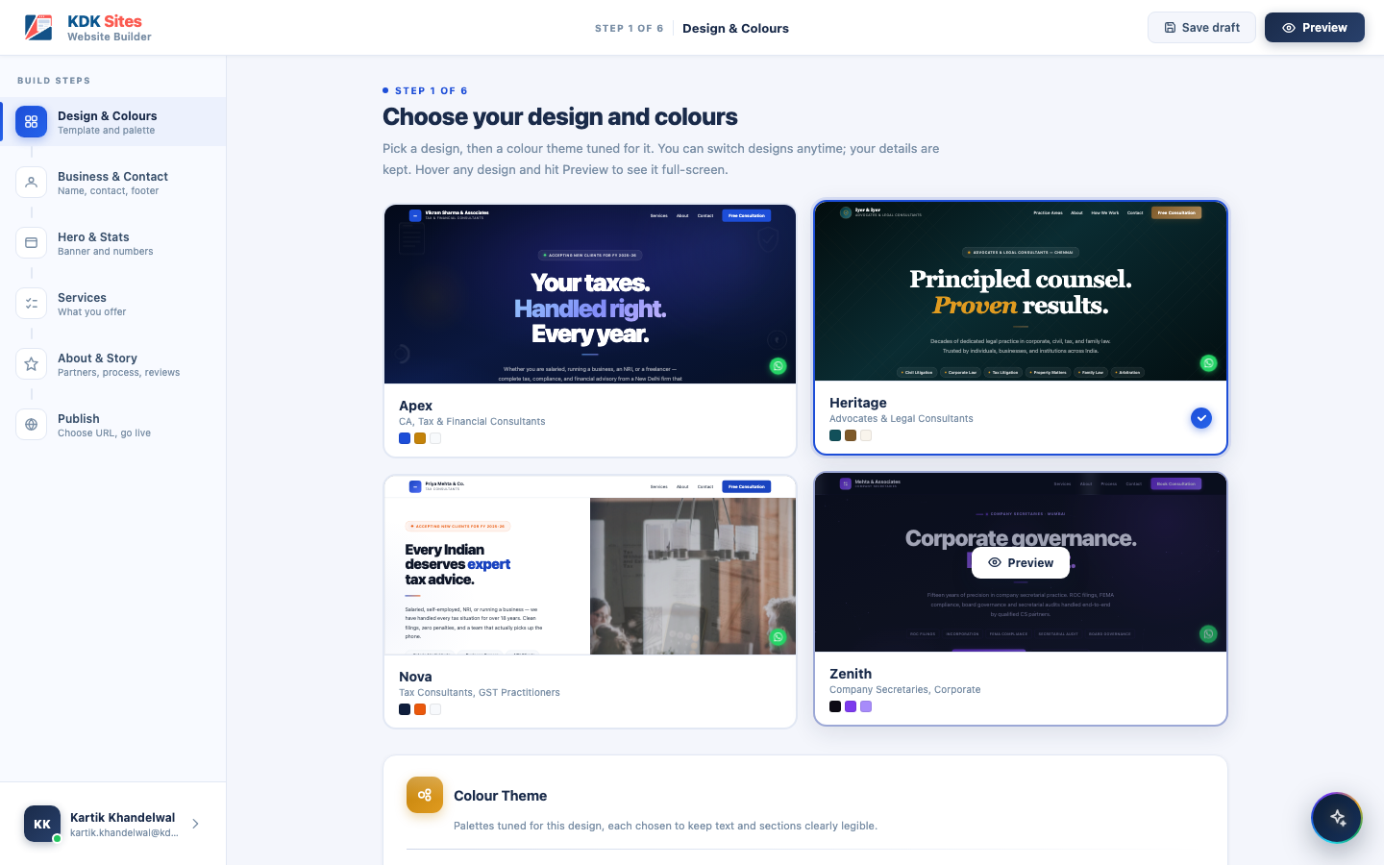
Step 1: Design & Colours
Each design carries its own set of 6 curated colour palettes, so the same layout can look completely different from one firm's site to the next. Switching either the design or the palette is instant and keeps every other answer the user has already given; only the look changes:
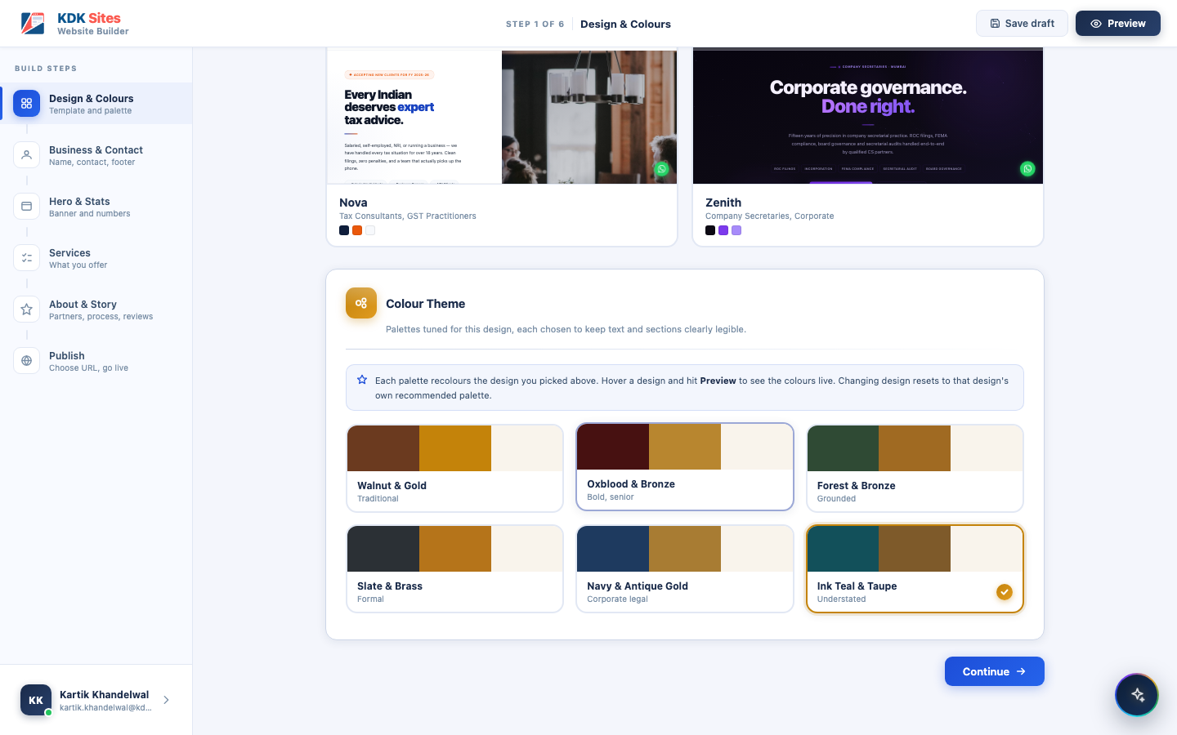
Step 1: Colour palette picker

Step 2: Business & Contact
The firm's identity and how clients reach them. This step is split into four sections:
- Firm Identity: profession, firm/practice name, tagline, founded year, team size, city, and an optional firm logo.
- Contact Information: phone number, WhatsApp number, email, office hours, office address, and optional membership/registration numbers (e.g. an ICAI membership number for a CA, or a firm registration number).
- Social Media Links: LinkedIn, Facebook, Instagram, YouTube. Each is optional; leaving one blank hides its icon on the published site rather than showing a broken or dead link.
- Footer: a short footer blurb and the copyright line shown at the bottom of every page. “Powered by KDK Software” is added automatically and cannot be removed.
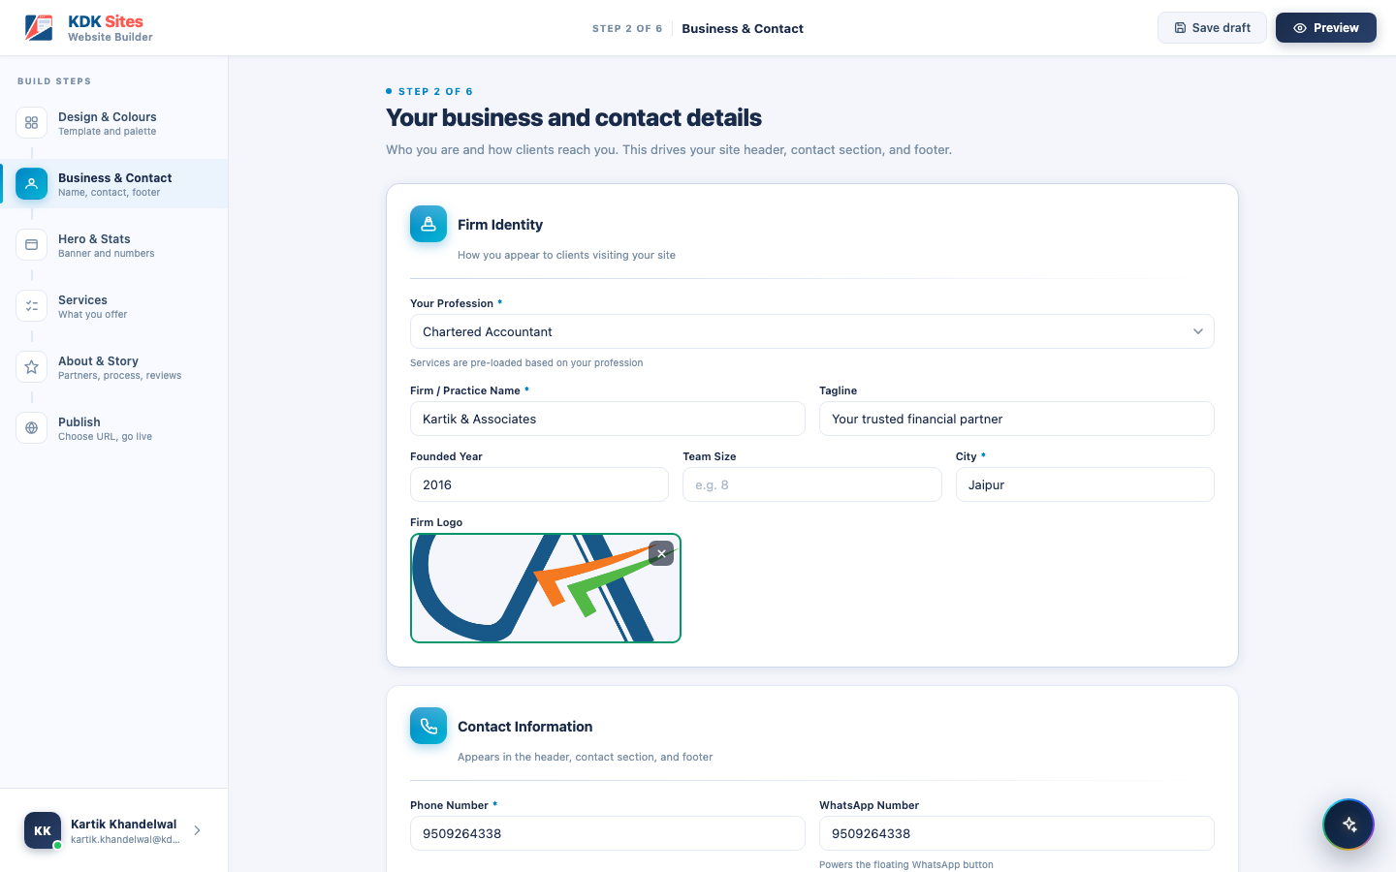
Step 2: Firm Identity and the start of Contact Information
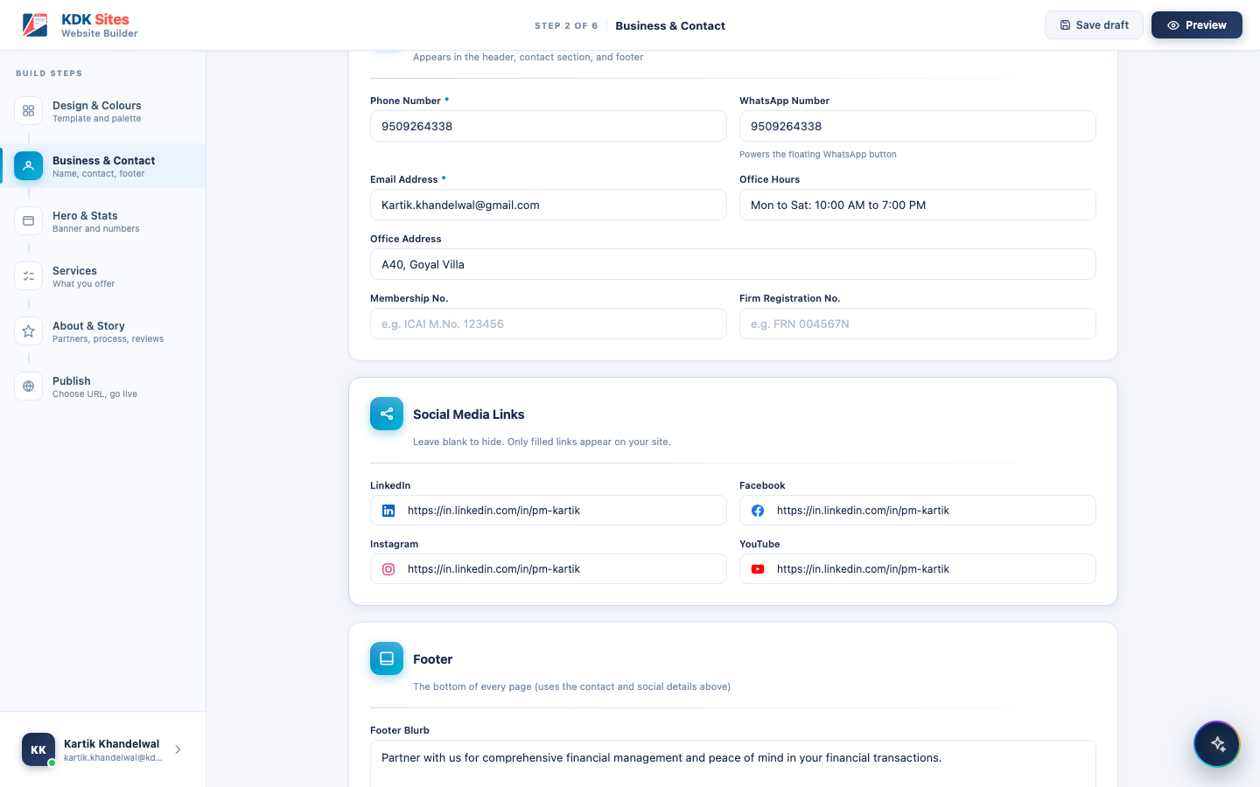
Step 2: Contact Information continued, and Social Media Links
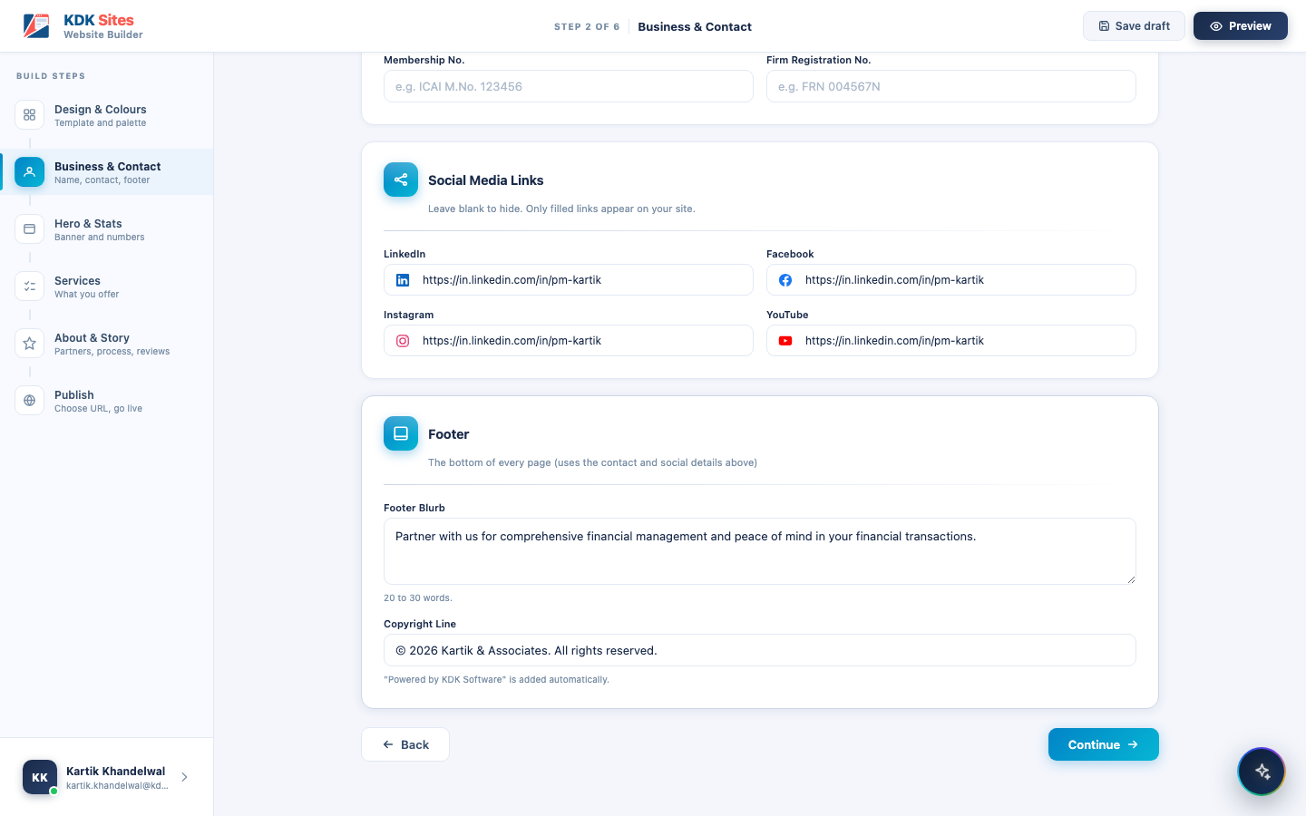
Step 2: Social Media Links and Footer

Step 3: Hero & Stats
The banner text and key numbers a visitor sees first. This step covers:
- Hero Banner: an eyebrow badge (e.g. “Now accepting clients for FY 2025-26”), the headline, a highlighted phrase within it (shown in the site's accent colour), a sub-heading, primary and secondary call-to-action buttons, and audience tags (short labels like “Small Businesses” or “NRI Clients” shown under the hero).
- Key Stats: up to 6 numbers that build trust (clients served, years of practice, ratings, on-time percentage, etc.), each with a quick-insert button for common symbols (★, ₹, +, %, ✓). This follows the same “3 to 6, or none at all” reasoning as the AI Writer's equivalent screens (Section 6.7, 6.8). The manual builder itself does not block a half-filled set, but the same design reasoning applies: a stats strip with one or two numbers looks unfinished.
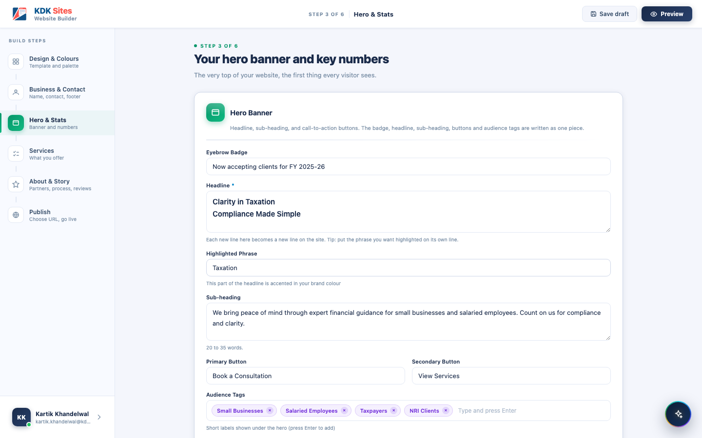
Step 3: Hero Banner
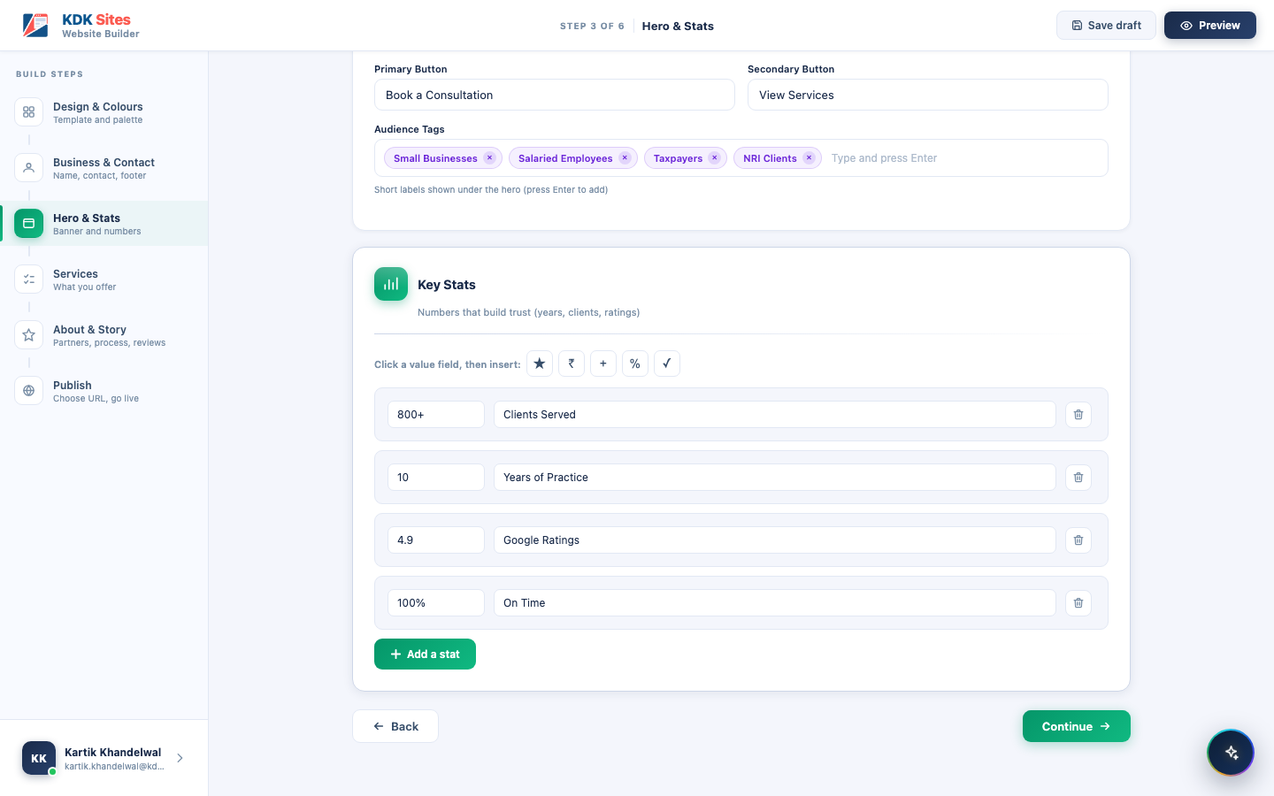
Step 3: Buttons, Audience Tags, and Key Stats

Step 4: Services
The profession's starter services, editable and extendable. Every pre-loaded service (Section 3.3) can be switched on or off with a toggle, and its name and description can be freely edited. A text box at the bottom lets the user add entirely custom services beyond the starter list, useful for a firm that offers something not in the standard set (e.g. “Virtual CFO Services”).
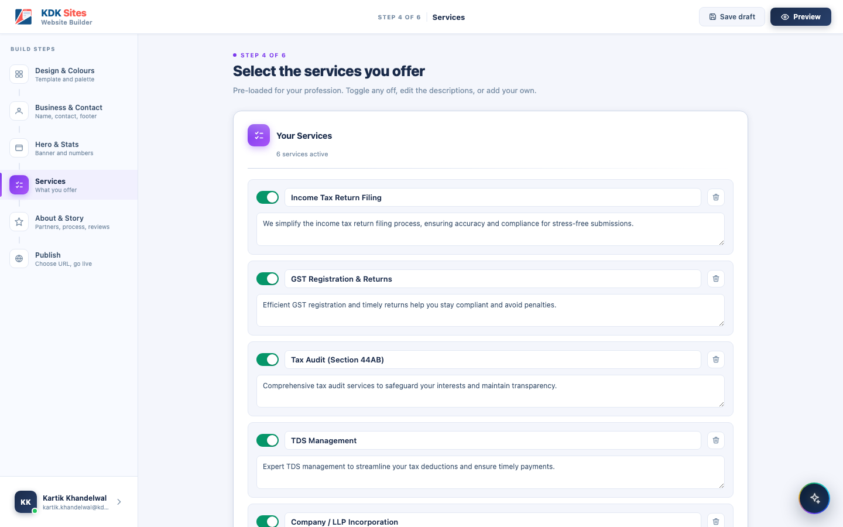
Step 4: Services list
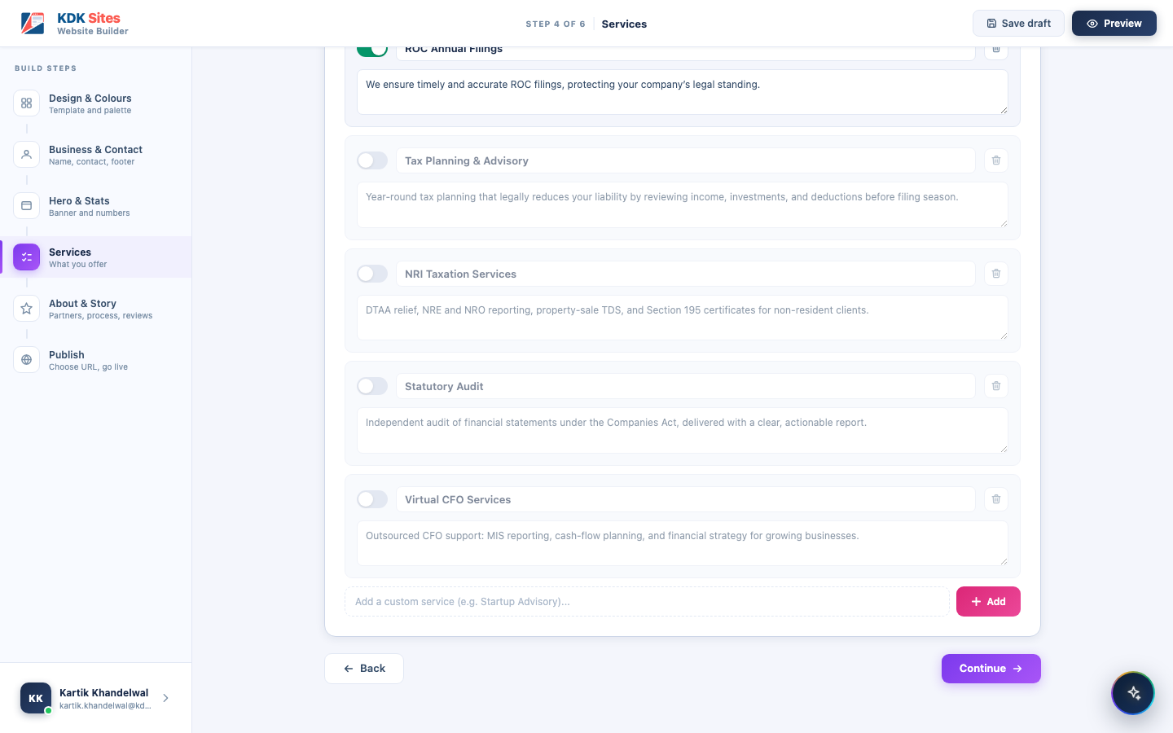
Step 4: More services, and the “Add a custom service” box

Step 5: About & Story
The firm's story, partners, process, and reviews. This is the largest step, split into five sections:
- About Your Firm: a short introduction (45 to 70 words) shown in the About section.
- Founders & Partners: up to 4 partners, each with a name, role/designation, an optional portrait (auto-cropped to a square), and a short bio with credentials (one per line, rendered as bullet points).
- About Highlights: exactly 3 short selling points shown alongside the About section (e.g. “Deep Experience,” “Fast GST Services,” “Error-Free Filing”), each with a one-line explanation.
- How We Work: 3 to 5 numbered steps describing the client journey, shown as a connected row of cards on the published site.
- Client Testimonials: optional; if used, 3 to 6 reviews, each with a star rating, quote, client name, role/company, and an optional photo.
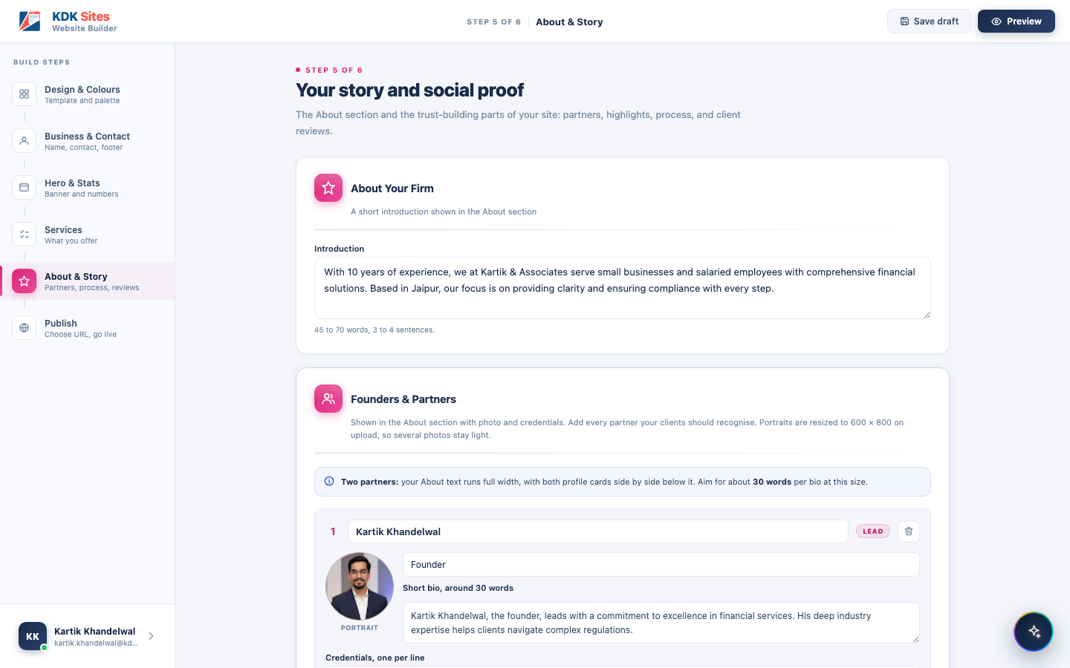
Step 5: About Your Firm, and Founders & Partners
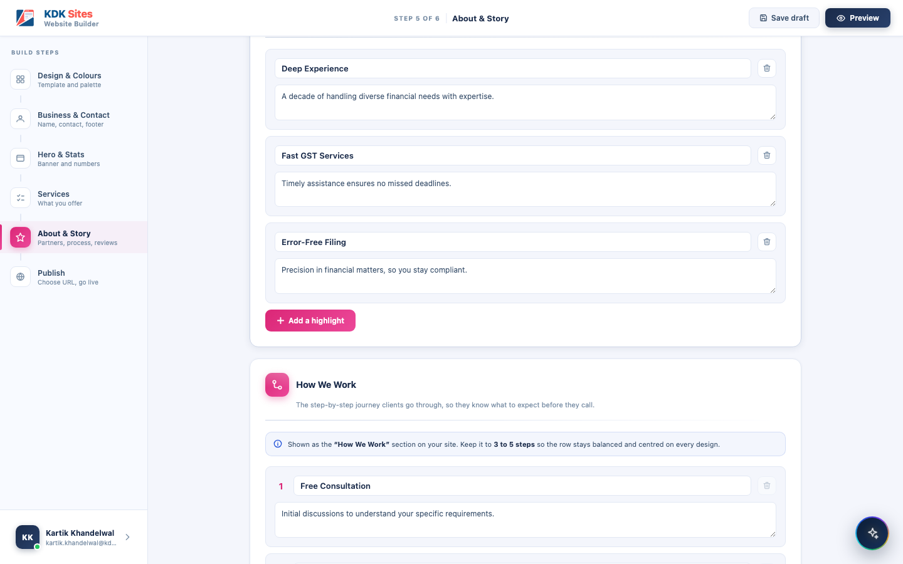
Step 5: About Highlights, and How We Work
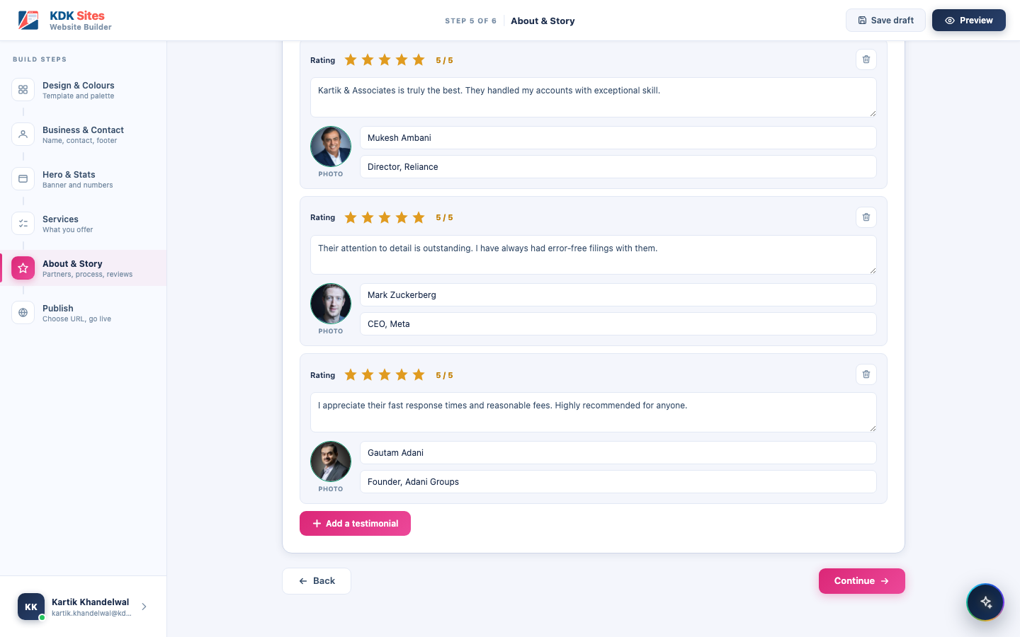
Step 5: Client Testimonials

Step 6: Publish
The live preview, the web address, and every control for managing a live site. What this screen shows depends entirely on where the site currently stands: there are five distinct states, not one static screen:
1. Never published yet.
The very first time a user reaches this step, there is no live site to show: only a preview of what will go live, a checklist confirming what is included, and a single Launch Website button (shown disabled until the typed address is confirmed available).
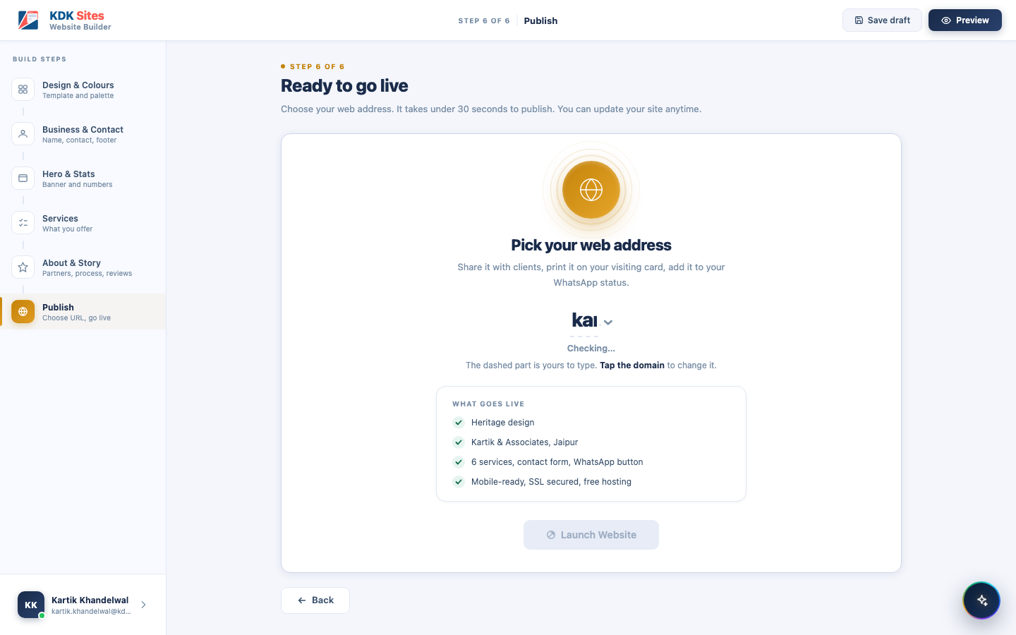
Step 6: before the first publish, “Ready to go live”
2. Live, with changes not yet published.
After the first publish, any further edit anywhere in the builder puts the site into this state: the live preview still shows what visitors currently see, but a banner makes clear that newer changes are waiting. The buttons are Publish changes, Change address, and Unpublish.
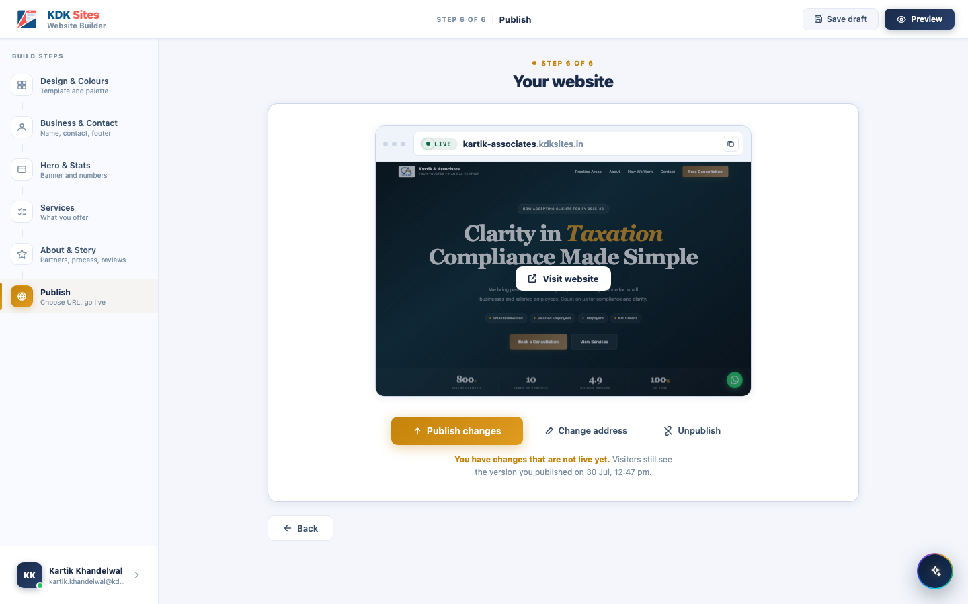
Step 6: unpublished changes waiting to go live
3. Live, and fully up to date.
Once “Publish changes” is pressed (or nothing has been edited since the last publish), the hint changes to confirm the site matches what's live, and there is nothing to publish: only Change address and Unpublish remain.
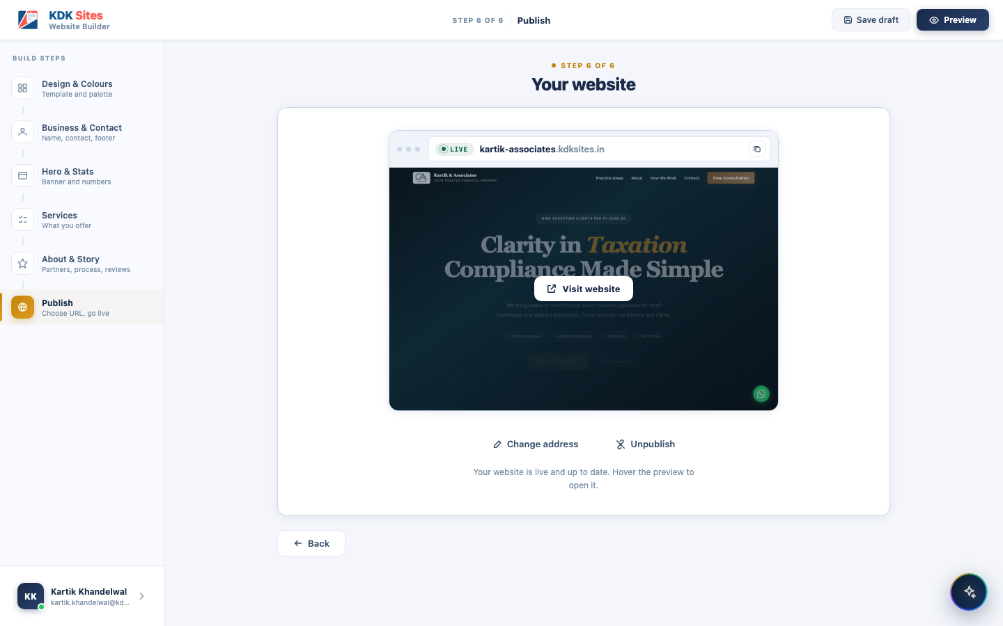
Step 6: live and up to date, nothing pending
4. Taken offline (unpublished).
After pressing Unpublish, the preview dims and is stamped “NOT PUBLISHED,” the browser-style bar shows an “OFFLINE” badge, and the only actions are Publish again and Change address. The address itself is never released, so nobody else can claim it while the site sits offline.
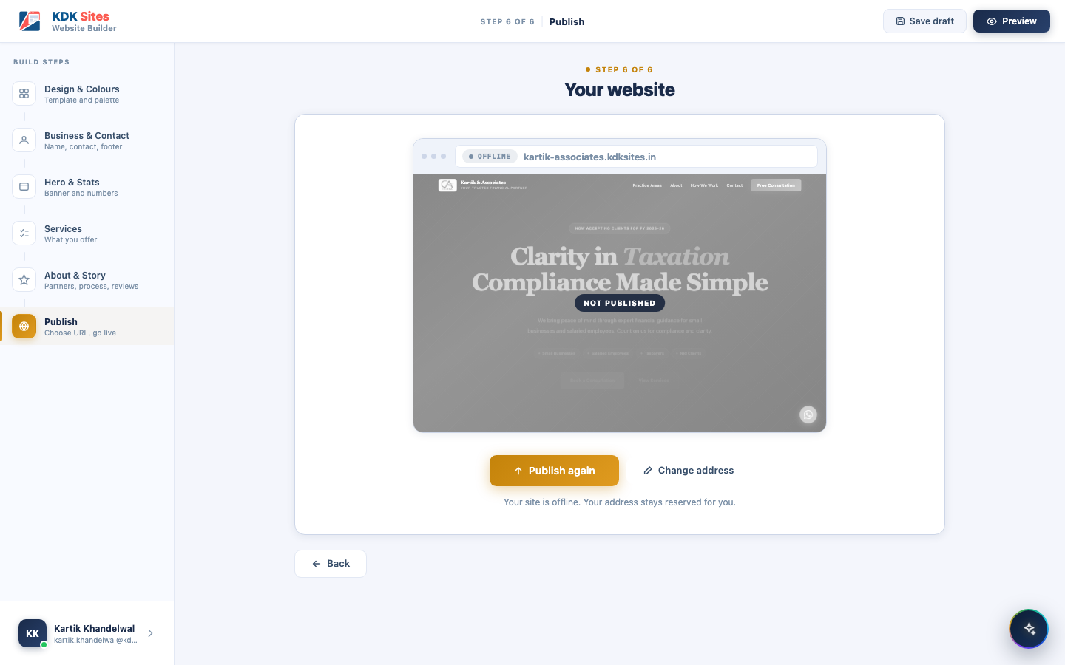
Step 6: site taken offline
5. Changing the address.
Pressing Change address (available in every state except “never published”) opens the address field for editing in place: nothing else on the page changes shape. Typing a new name shows where the site would move to; the current address keeps working normally until the user actually confirms the move by publishing. Cancelling reverts to the address currently live.
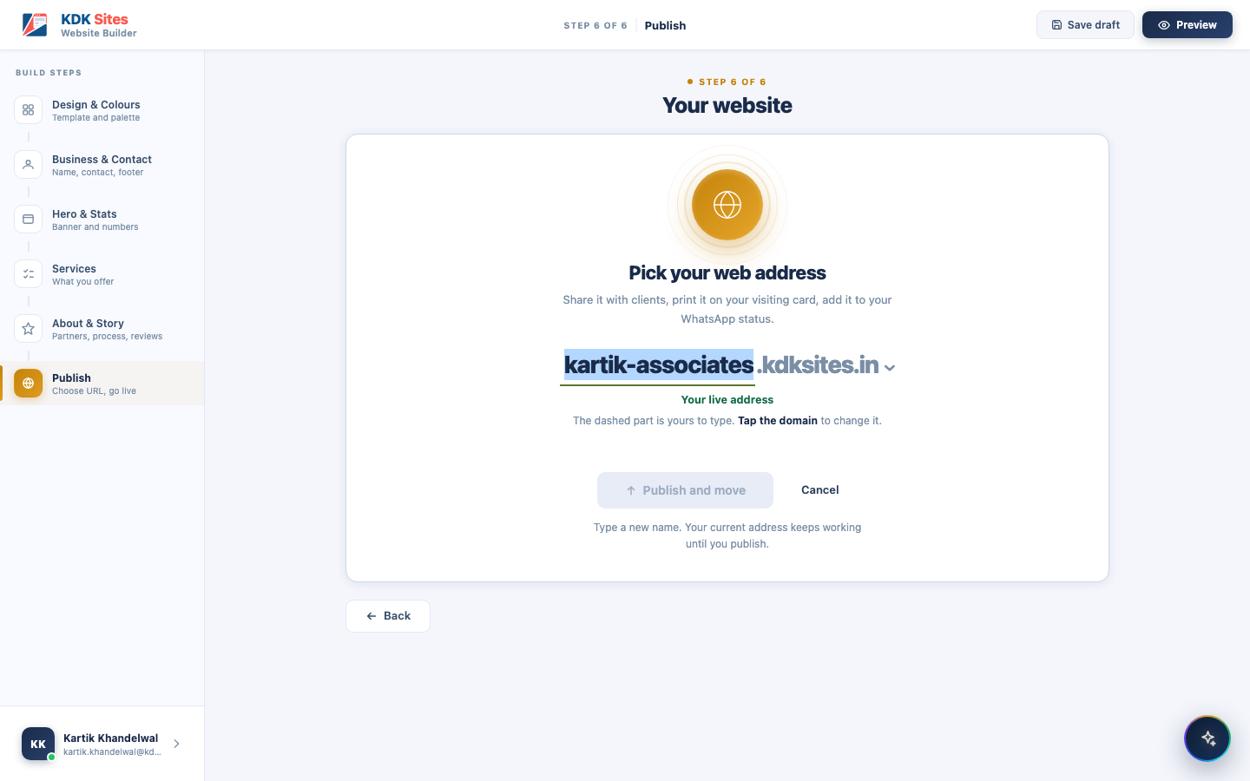
Step 6: the change-address panel open
Two more rules worth knowing:
- The address is a pair (a subdomain plus a domain; Section 7 covers the domain pool). Moving a live site to a new address is treated as a real, one-way move: the old address is released the instant the new one is confirmed, so the system asks the user to confirm it by name before doing so.
- Publishing is always gated on every step being complete. Pressing Launch Website / Publish changes re-checks every required field across Steps 2 to 6 (not just Step 6 itself) and, if anything is missing, jumps the user straight to the first incomplete step rather than failing silently.

Open Question: How Many Times Can a Site Be Published?
OPEN QUESTION There is currently no limit anywhere in the product on how many times a professional can publish or re-publish their site. Every “Publish changes” click goes live immediately, with no daily cap, cooldown period, or review step in between. Whether a limit should exist (for abuse prevention, cost control, or as a lever tied to a future paid plan) has not been decided. This is flagged here as an open question, not an oversight: any future limit would change a promise this document currently makes throughout, that publishing is instant and always available.

5.5 The AI Website Writer
This is a short, conversational interview (7 screens plus a final review) that stands in for typing everything out by hand.
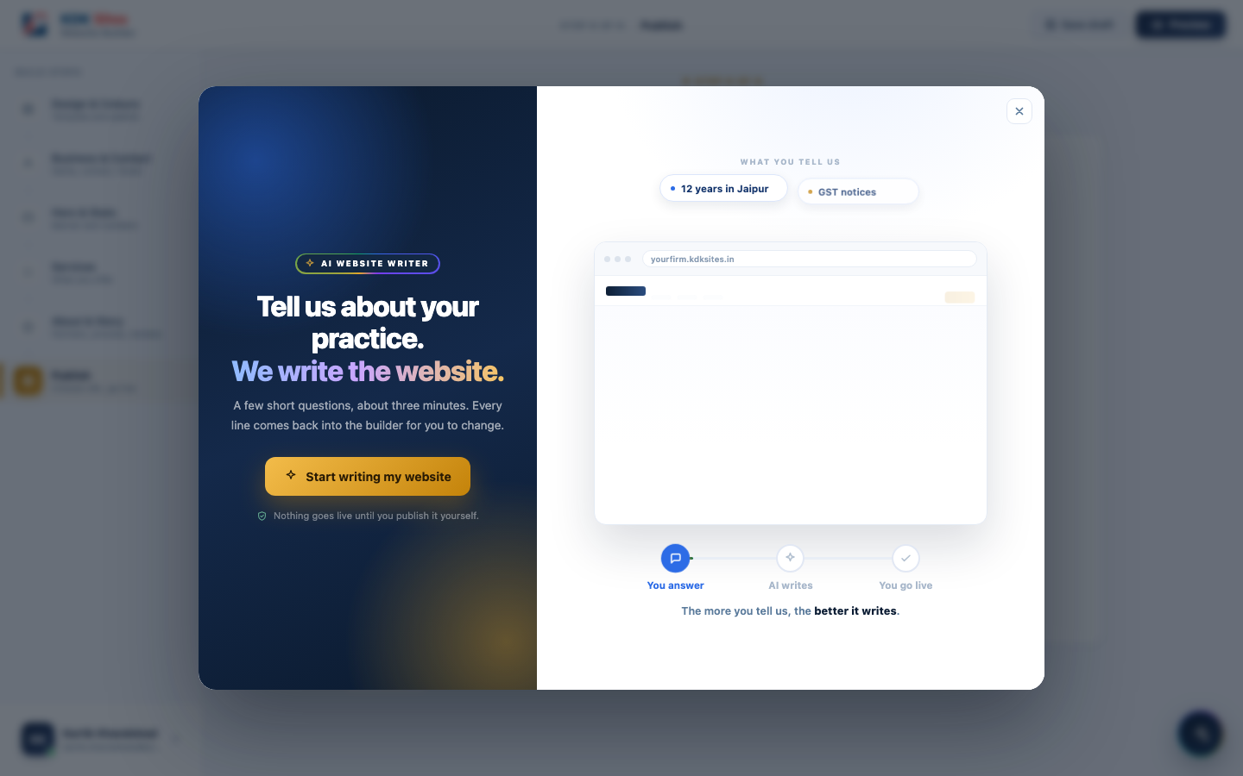
AI Website Writer: introduction screen
What it asks, screen by screen:
- Your practice: profession, firm name, years practising
- What sets you apart: what you're best known for, your typical clients, and (optionally) key numbers to show off
- How you work: a step-by-step description of your process
- Founders & partners: name, role, and photo for each
- Client reviews: optional testimonials
- Contact details: city, phone, email, office address, office hours, social links
- Anything else: a free-text box for anything not already covered (awards, languages, specialisations)
- Review & write: a final summary before the AI generates the site
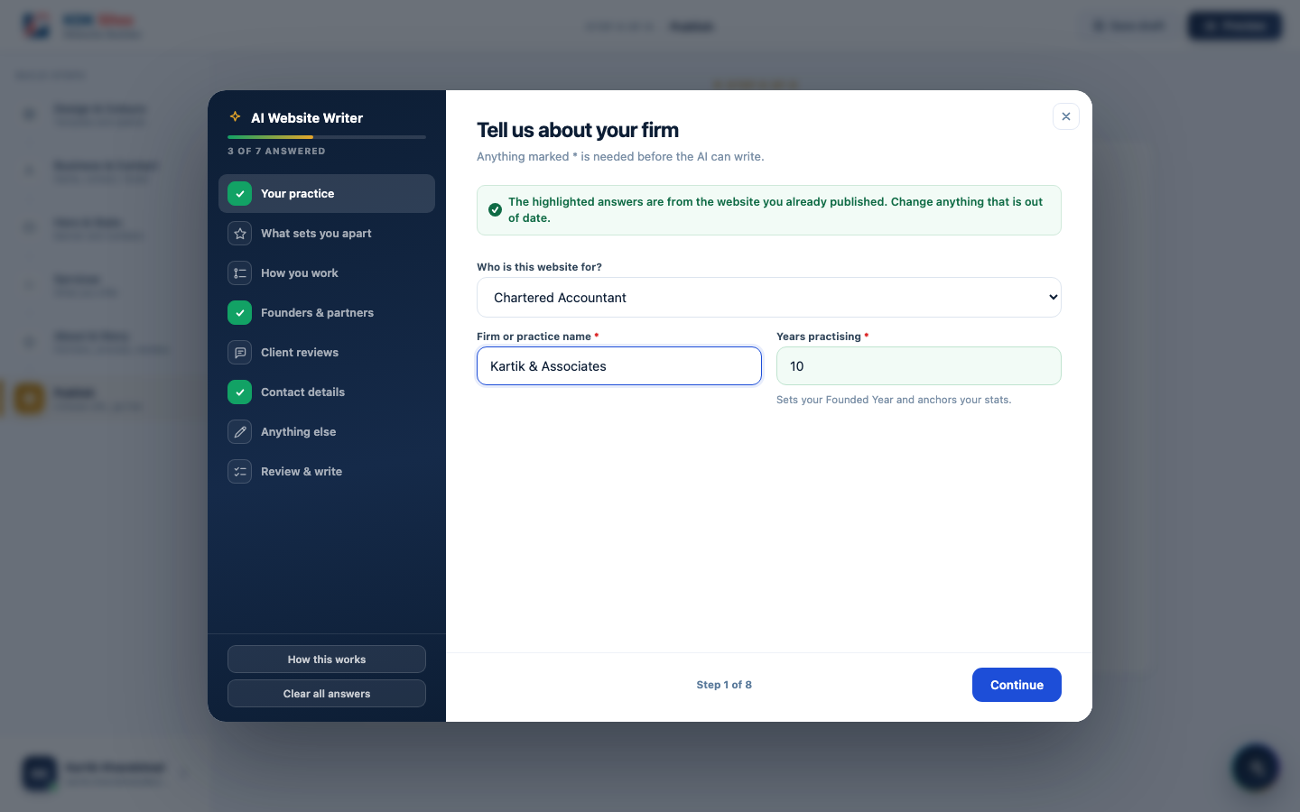
AI Website Writer: an answer screen
What makes it easier for a returning user: if the firm already has a published site, opening the AI Writer automatically fills in every plain fact it already knows: firm name, city, years in practice, phone, email, address, office hours, social links, and every partner's name, role, and photo (shown highlighted in green below, with a note explaining where each came from). Only the more subjective, judgement-based answers (what you're known for, your typical clients, your review notes) are left blank for the user to (re)describe. This is because the site only stores the AI's polished write-up of those answers, not the user's original rough notes, and feeding the polished text back in as a “question” just produces blander answers on a second pass.
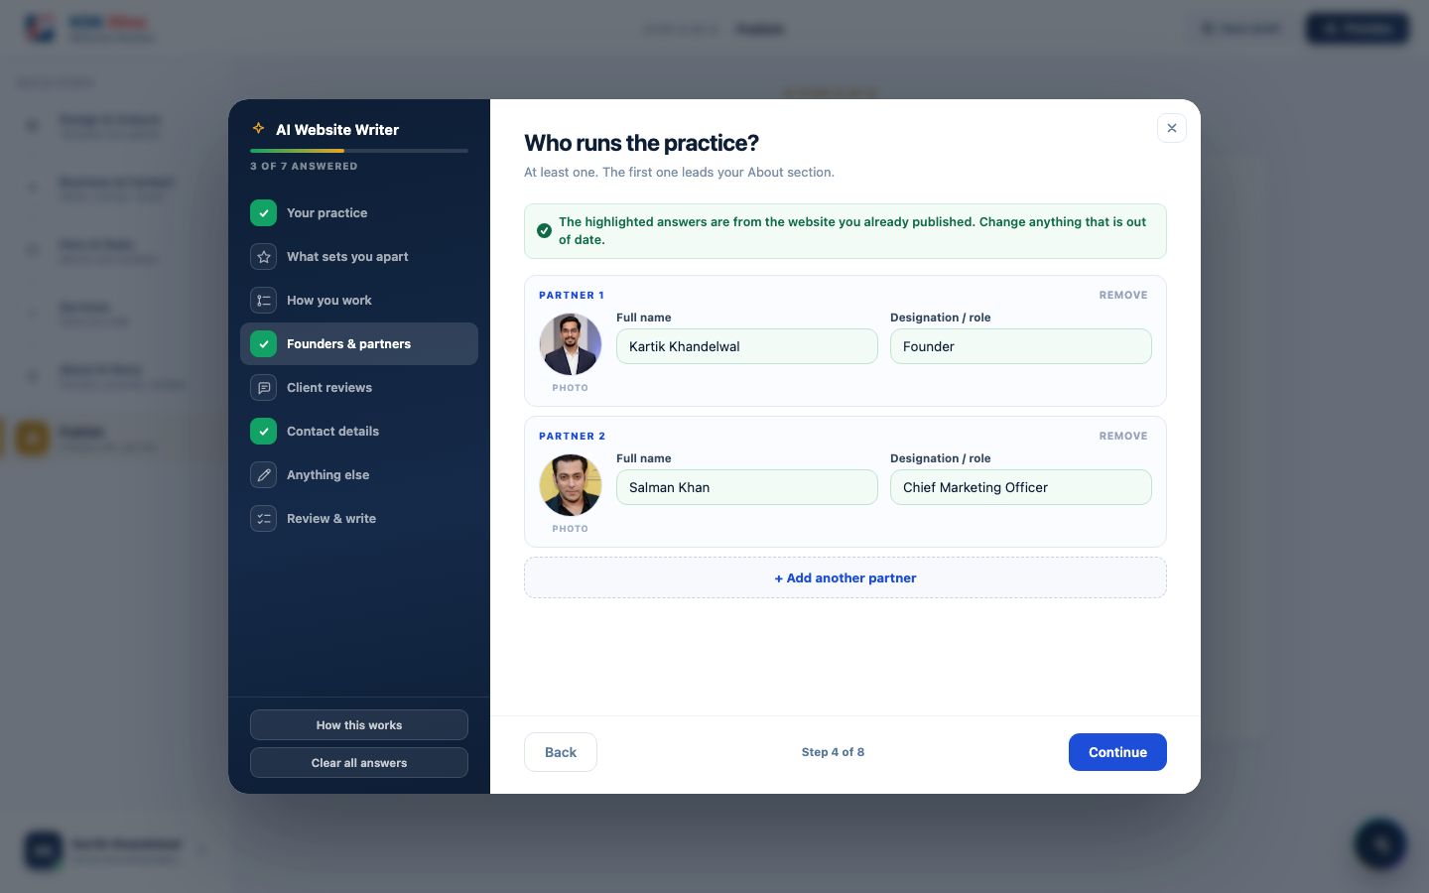
AI Website Writer: founders & partners, prefilled from the live site
Safety net: every required question is checked twice, once as the user moves between screens, and again the moment they click “Write my website”. This makes it impossible to jump ahead using the review screen and generate a site that is missing a mandatory answer.
Once the interview is complete, an AI service (run securely on KDK's servers, not in the visitor's browser) writes the actual website copy and drops it into the same 6-step wizard, ready for the user to review, tweak, or publish immediately.

5.6 Managing Enquiries
Every website has a contact form. When a visitor submits it, the enquiry is saved instantly into a built-in Enquiries inbox inside the builder. The professional does not need any other tool to see it.
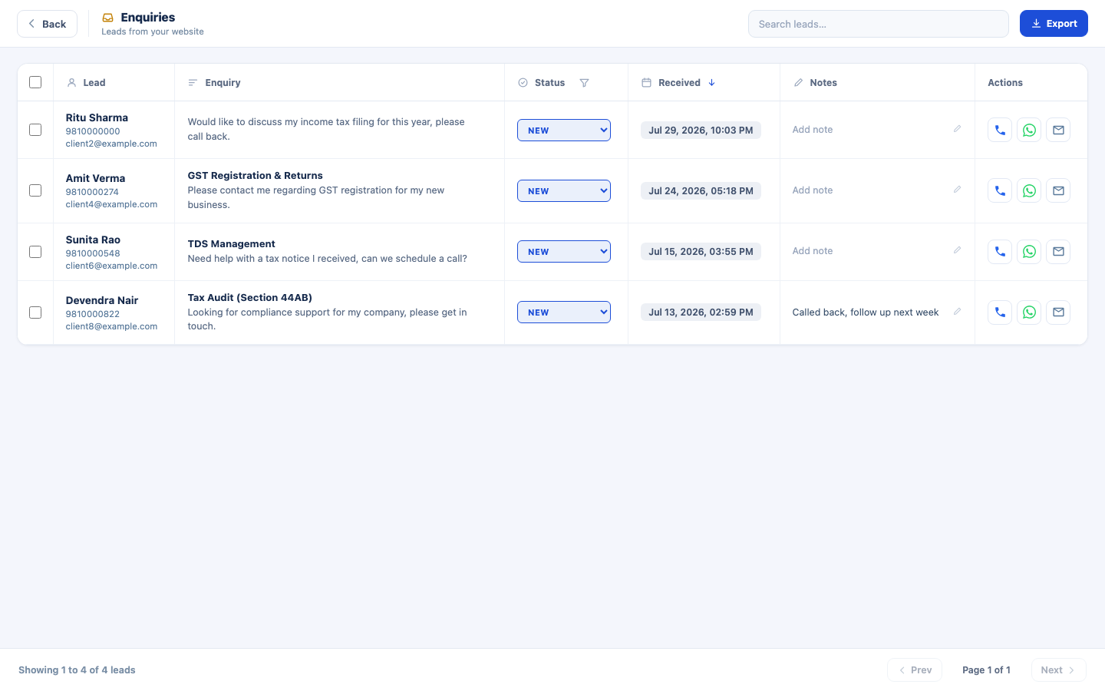
The built-in Enquiries inbox
NOTE The names, numbers, and messages shown above are illustrative examples, not real visitor data, swapped in only for this document.
From that inbox the professional can:
- Search and filter enquiries by status (new, in progress, done, etc.)
- Add private notes to any enquiry
- Call, WhatsApp, or email the visitor directly from the same screen
- Export enquiries to Excel, either individually selected or all at once

6. Functional Requirements & Validation Rules
This section lists exactly what is required on every screen, and the rule the product enforces for each field. Anything not listed as required is optional. Each rule is written so both a non-technical reader and a developer can follow it.

6.1 Manual Builder, Step 1: Design & Colours
Field | Required? | Validation rule
Website design | Always set | There is no “unselected” state: every account starts on a default design (Apex) with its first colour palette already applied, so nothing blocks progress here. The user can switch to any of the other 3 designs at any time, and switching keeps all of their content; only the look changes.
Colour theme | Always set | Same as above: a palette from the chosen design's set of 6 is always active by default. Picking a different one is optional and instant. There is nothing to “submit”; the live preview updates immediately.

6.2 Manual Builder, Step 2: Business & Contact
Field | Required? | Validation rule
Profession | Yes | Must be selected from the list of 6 supported professions
Firm / practice name | Yes | Cannot be left blank
City | Yes | Cannot be left blank
Phone number | Yes | Cannot be left blank
Email address | Yes | Cannot be blank, and must be in a valid email format (some text, an @ symbol, more text, a dot, more text, e.g. you@yourfirm.in)
Firm logo / any photo upload | No | If a file is chosen, it must be an image (PNG, JPG, SVG, WebP, or GIF) and no larger than 2 MB for a logo, or 5 MB for any other photo. A file outside these limits is rejected with a clear message rather than silently failing.

6.3 Manual Builder, Step 3: Hero & Stats
Field | Required? | Validation rule
Hero headline | Yes | Cannot be left blank
Key numbers (stats) | No | Optional. If none are added, the section is left out entirely

6.4 Manual Builder, Step 4: Services
Field | Required? | Validation rule
Services shown on the site | At least 1 | At least one service must be switched on before the user can continue

6.5 Manual Builder, Step 5: About & Story
Field | Required? | Validation rule
Founders / partners | At least 1 | At least one partner must have a name entered
Partner / reviewer photo | No | Same image-file rule as above: accepted formats only, 5 MB ceiling. Every accepted photo is automatically cropped to a square before it's stored, since every design displays it that way.
Firm story, process steps, client reviews | No | All optional. Any section left empty is hidden from the published site rather than showing placeholder content

6.6 Manual Builder, Step 6: Publish
Field | Required? | Validation rule
Web address (subdomain) | Yes | Cannot be blank. Must be at least 3 characters, and may only contain lowercase letters, numbers, and hyphens (no spaces or other symbols). Must also pass a live availability check confirming nobody else already holds that address.

6.7 AI Website Writer, Screen 1: Your Practice
Field | Required? | Validation rule
Profession | Yes | Must be selected
Firm / practice name | Yes | Cannot be left blank
Years practising | Yes | Cannot be left blank. This is the one number the AI can always rely on: it sets the firm's “Founded Year” and anchors any stats the AI writes if no key numbers were supplied.

6.8 AI Website Writer, Screen 2: What Sets You Apart
Field | Required? | Validation rule
What you're best known for | Yes | At least 2 entries required
Your typical clients | Yes | At least 2 entries required
Key numbers worth showing | No | Optional, but if any are added, at least 3 must be added (up to a maximum of 6). A half-filled set (1 or 2 entries) is not allowed, because the stats strip on the published site is designed to hold several numbers, and a couple of entries would look incomplete. The AI never invents a number the user did not provide.

6.9 AI Website Writer, Screen 3: How You Work
Field | Required? | Validation rule
Process steps | Yes | At least 3 steps required (maximum 5). The “How We Work” section is a row of connected cards, and fewer than 3 reads as unfinished.

6.10 AI Website Writer, Screen 4: Founders & Partners
Field | Required? | Validation rule
At least one partner | Yes | At least 1 partner row required (maximum 4)
Each partner's name | Yes, per row started | Any partner row that has been started must have both a name and a role before the interview can continue
Each partner's role/designation | Yes, per row started | Same as above: required alongside the name, because the AI uses the role to make each partner's write-up distinct rather than four near-identical paragraphs
Partner photo | No | Optional

6.11 AI Website Writer, Screen 5: Client Reviews
Field | Required? | Validation rule
Reviews | No | Entirely optional. The whole section can be skipped. But if the user adds any review, at least 3 are required (maximum 6). Skipping this screen keeps whatever reviews already exist on a previously published site untouched.
Each review's client name | Yes, per row started | Any review row that has been started must have both a name and a note before the interview can continue
Each review's note | Yes, per row started | Same as above: required alongside the name, since the note is what the AI turns into the polished review; a name with no note would force the AI to invent the review's content

6.12 AI Website Writer, Screen 6: Contact Details
Field | Required? | Validation rule
City | Yes | Cannot be left blank
Phone number | Yes | Cannot be left blank
Email address | Yes | Cannot be blank, and must be in valid email format
Office address | Yes | Cannot be left blank. This field cannot be invented by the AI, and every template shows a real address or none, never a sample one.
Office hours | Yes | Cannot be left blank. Pre-filled with a common default (Mon to Sat: 10:00 AM to 7:00 PM) that the user can edit or keep.
Social media links | No | Optional. Each one supplied becomes an icon in the site's footer.

6.13 The Rule Behind All of This: No Placeholder Content on a Live Site
Across every screen above, the product follows one consistent principle: if a field is genuinely optional and the user leaves it empty, that section of the website disappears. It never falls back to showing the template's own sample text. For example, a firm that adds no client reviews gets no testimonials section at all, rather than the design's built-in sample quotes. A firm that provides no key numbers gets no stats strip, rather than an invented one. This is treated as a hard product rule, not a preference: any new field added to the builder in future must have a clear, deliberate answer to “what does the published site show if this is left blank?”

7. Finalised Domain Names
Every published site needs a web address in the form <firm-name>.<domain>. KDK is building a small pool of its own domain names so a professional can pick the one that best suits their profession, rather than every site sharing a single generic address.
Domain | Positioning | Status
kdksites.in | The general, all-profession KDK Sites address | Live: this is what every site currently publishes to
CAworld.in | Chartered Accountants | Name finalised, not yet purchased
Mycafirm.in | Chartered accountancy firms | Name finalised, not yet purchased
caone.ai | Modern, tech-forward practices | Name finalised, not yet purchased
cadesk.app | A clean, app-style address | Name finalised, not yet purchased

Once a domain in this list is purchased and connected, it becomes selectable from the same address picker shown in Step 6 (Publish) above. No other change is needed anywhere else in the product.

8. Website Templates & Design System

8.1 The Four Designs
Design | Best for
Apex | Chartered Accountants, Tax & Financial Consultants (marked “Most Popular”)
Heritage | Advocates & Legal Consultants
Nova | Tax Consultants, GST Practitioners
Zenith | Company Secretaries, Corporate professionals

Each design offers 6 curated colour palettes of its own (24 combinations in total), each checked to make sure colours are genuinely distinguishable from one another and that text stays easily readable against its background.
Below is each design as a visitor actually sees it, shown here with each template's own placeholder content (a real, published site shows the professional's own name, photos, and text in exactly this layout):
Apex
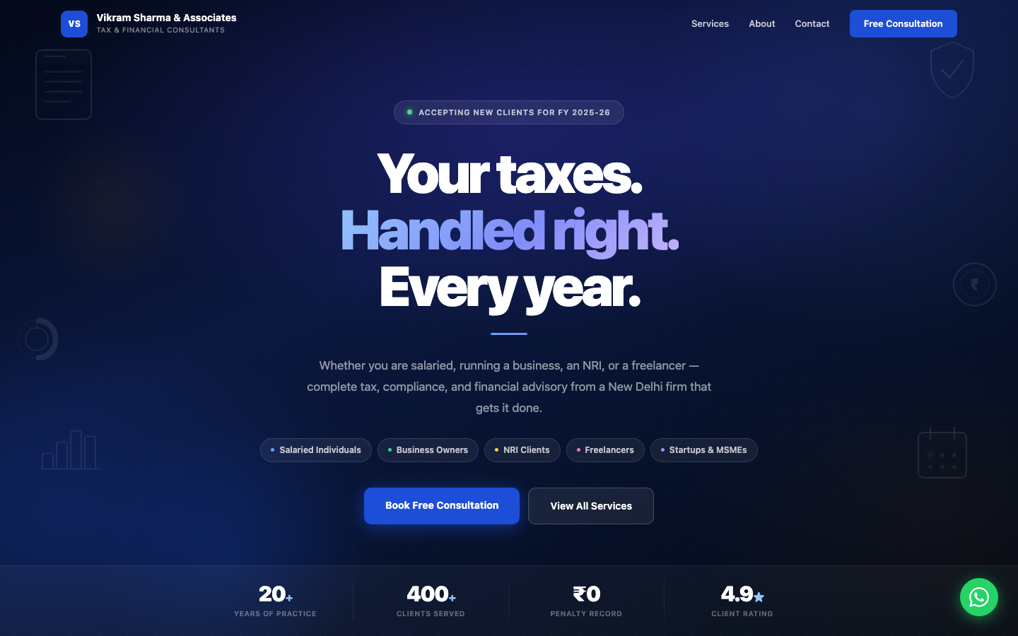
Heritage
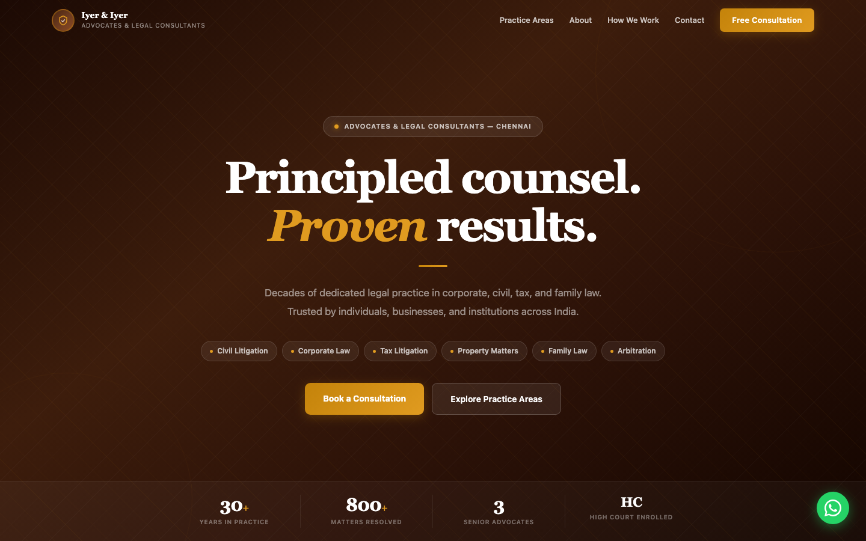
Nova
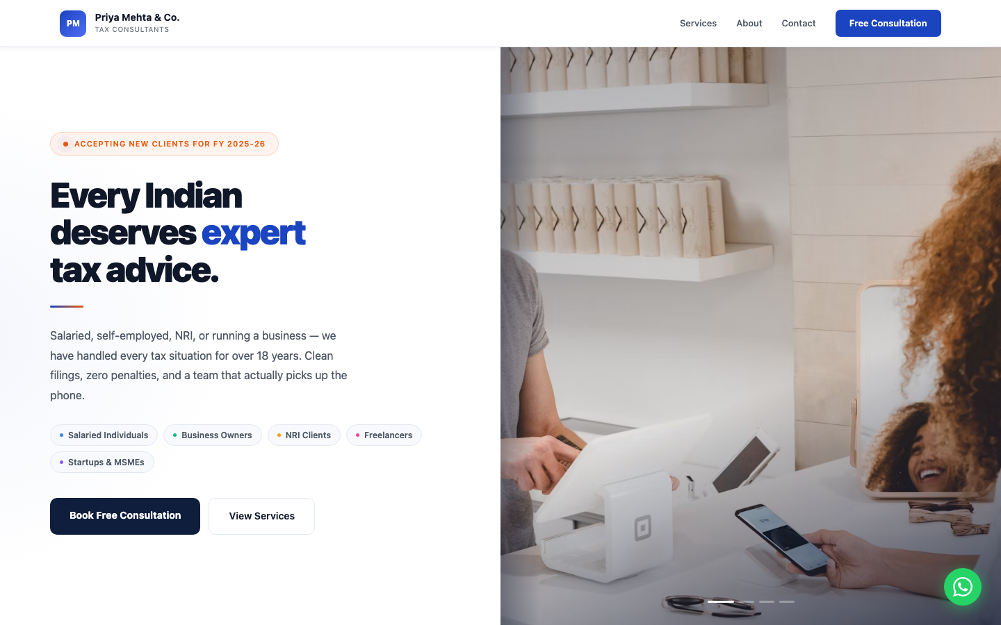
Zenith
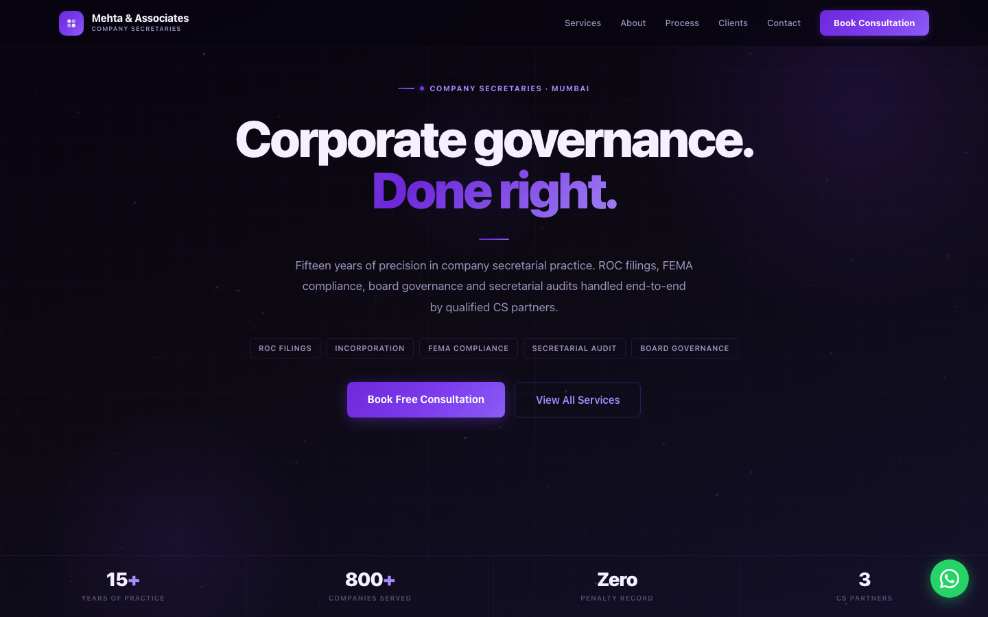

8.2 What Every Published Site Includes
Regardless of which design is chosen, every published site has the same set of sections, populated with that firm's own content:
- Navigation bar: firm name/logo and menu, becomes solid on scroll
- Hero banner: firm name, tagline, and calls to action
- Key numbers: up to 6 stats, if the user chose to add them
- Services: the profession's services, as toggled/edited by the user
- About: firm story and credentials
- Founders/Partners: photo, name, and role for each
- How We Work: a numbered process, at least 3 steps
- Client Reviews: testimonials, if the user chose to add them
- Contact: details, an enquiry form, and a floating WhatsApp button
- Footer: firm details and “Powered by KDK Software”

8.3 Design Principles
- No emoji anywhere: icons are hand-drawn, geometric line icons
- No Google Fonts or other external assets: uses the device's own system font, so pages load instantly with nothing to download
- Every design is fully responsive on mobile, where the large majority of a professional's clients will view it
- Every published site is automatically secured (https/SSL): visitors never see a “not secure” warning

9. Non-Functional Requirements
Written for anyone checking “does this actually meet the bar,” not just developers:
Requirement | What it means in practice
Speed | Pages should feel instant. No large downloads, no waiting on external fonts or scripts.
Mobile-first | Every screen, in the builder and on published sites, must work cleanly on a phone, not just a desktop.
Security | Every published site is served over https automatically. The AI's underlying key/credentials are never exposed to a visitor's browser. All AI requests go through KDK's own server-side service.
Accounts stay private | A professional's draft and published site are tied to their login; nobody else can see or edit them.
Reversibility | Taking a site offline always asks for confirmation first, and is always recoverable. There is currently no way to permanently delete a site at all; Unpublish (reversible) is the only way down.
No broken defaults | A skipped field must never show someone else's placeholder text on a real, live website (Section 6.13).
Availability | Once published, a site should stay reachable continuously; taking it down is something only its owner does deliberately.

10. SEO: Getting Published Sites Found on Google
Every published site automatically gets the technical groundwork search engines look for: an accurate page title and description drawn from the firm's real details (not template placeholder text), a clean preview image and link summary for when the site is shared on WhatsApp, and a structured, machine-readable summary of the business (name, phone, address, hours, services) that can help a Google search result show more than just a plain blue link. None of this requires the professional to do anything extra: it's generated automatically from whatever they typed into the builder, and updates itself the next time they publish a change.
Two things are known, current limitations rather than something to quickly fix:
- A KDK-provided address (name.kdksites.in) will generally rank a little behind a firm's own domain name. This is true of every website builder, not unique to this product, and is part of why a wider pool of finalised KDK-owned domains (Section 7) is being built out.
- Since every site uses one of only four templates, at large scale (thousands of live sites) Google can recognise the shared structure across firms, which may affect ranking. This is a byproduct of how any template-based builder works, and isn't fixable with a small code change.

